**EIT Digital gives visibility to female-led deep-tech ventures**

**News 02/12/2019**

[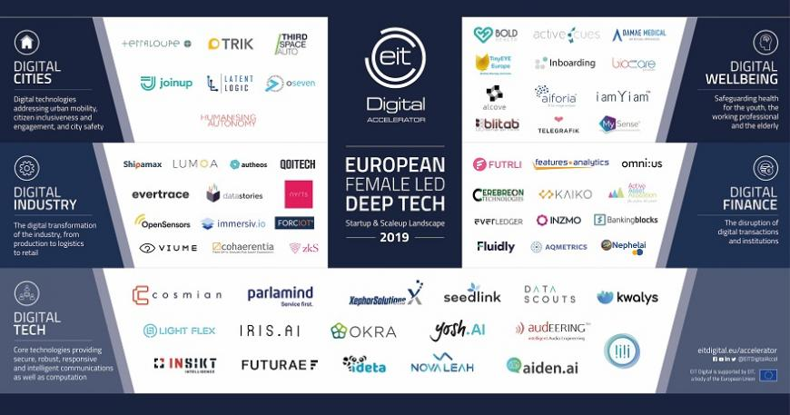](https://eit.europa.eu/sites/default/files/women-in-eu-dt_hires.jpg)

[**EIT Digital**](https://www.eitdigital.eu/)**provides visibility and support for women in deep-tech as it is a challenging field for female entrepreneurs.**

'Women founders have it tough. Women in ‘hard tech’ have it tougher' the US magazine Fast Company recently titled an [article](https://www.fastcompany.com/90422338/women-founders-have-it-tough-women-in-hard-tech-have-it-tougher) about the efforts of female Deep Tech founders to find investors for their technologies. Author Daniela Perdomo, co-founder and CEO of tech start-up goTenna quotes a Crunchbase survey that reports that female-led ventures receive 44% less funding than their fair share. For deep-tech, the numbers were even more staggering with 54% less VC funding raised for non-female business categories, and up to alarming 75% for infrastructure and wireless companies, even though just these technologies actually require more investment.

**State of European tech 2019**

Other reports do not draw a better picture for female founders and CEOs, According to the recently published report ['The State of European Tech 2019'](https://2019.stateofeuropeantech.com/chapter/diversity-inclusion/article/state-di-european-tech/)by Atomico, 92% of all funds raised by European VC-backed companies went to all-male founding teams. Looking at the gender composition in executive-level positions of tech scale-ups, the situation doesn’t look very promising either with data showing that for every woman executive, there are 12 men executives.

Still, for many investors, the image of a successful technology leader is associated with men. Hence, more efforts are needed to transform the stereotypical image of a tech leader and give more visibility to female entrepreneurs and their companies.

**Creating a Landscape for female-led deep-tech**

That’s why [EIT Digital](https://www.eitdigital.eu/)has created a Landscape giving visibility to female-led deep-tech ventures. The landscape comprises over 60 European companies with a female CEO arranged by the five deep tech categories, strategically chosen with respect to major digital trends and European leadership potential: Digital Tech, Digital Industry, Digital Cities, Digital Finance and Digital Wellbeing.